Lesson Set 12 | Introduction to Pointers
Purpose | - Understand the purpose and usage pointers  - Awareness of pointers with syntax and rules.  - Accessing value and address of variable in pointers  - Concept of pointers to Pointers
Procedure | - Students should read the Pre-lab Reading Assignment before coming to lab.  - Students should complete the Pre-lab Writing Assignment before coming to lab.  - In the lab, students should complete Labs 12.1 through 12.2 in sequence.  - Your instructor will give further instructions as to grading and completion of the lab.  - Students should complete the set of lab tasks before the next lab and get them checked by their lab instructor.
 | Contents | Pre-requisites | Completion Time | Page Number
 | Pre-lab Reading Assignment | - | 20 min
 | Pre-lab Writing Assignment | Pre-lab Reading | 10 min
 | Lab 12
 | Lab 12.1  Working with pointers | Understanding the Pointers | 30 min
 | Lab 12.2  Working with declaring and playing with pointers | Implementing the Pointers | 30 min

Pre-lab Reading Assignment

What is Pointers | C++ pointers are easy and fun to learn. Some C++ tasks are performed more easily with pointers, and other C++ tasks, such as dynamic memory allocation, cannot be performed without them.  As you know every variable is a memory location and every memory location has its address defined which can be accessed using the ampersand (&) operator which denotes an address in memory. Consider the following which will print the address of the variables defined −  #include <iostream>  using namespace std;  int main () {  int var1;  char var2[10];  cout << "Address of var1 variable: ";  cout << &var1 << endl;  cout << "Address of var2 variable: ";  cout << &var2 << endl;  return 0;  }  When the above code is compiled and executed, it produces the following result −  Address of var1 variable: 0xbfebd5c0  Address of var2 variable: 0xbfebd5b6  Here, 0x at the beginning represents the address in the hexadecimal form. Notice that the first address differs from the second by 4 bytes and the second address differs from the third by 4 bytes. This is because the size of an int variable is 4 bytes in a 64-bit system.  Note: You may not get the same results when you run the program.  What are Pointers?  A pointer is a variable whose value is the address of another variable. Like any variable or constant, you must declare a pointer before you can work with it. The general form of a pointer variable declaration is −  type *var-name;  Here, type is the pointer's base type; it must be a valid C++ type and var-name is the name of the pointer variable. The asterisk you used to declare a pointer is the same asterisk that you use for multiplication. However, in this statement, the asterisk is being used to designate a variable as a pointer. Following are the valid pointer declarations −  int *ip; // pointer to an integer  double *dp; // pointer to a double  float *fp; // pointer to a float  char *ch // pointer to character  The actual data type of the value of all pointers, whether integer, float, character, or otherwise, is the same, a long hexadecimal number that represents a memory address. The only difference between pointers of different data types is the data type of the variable or constant that the pointer points to
Get the Value from the Address Using Pointers
To get the value pointed by a pointer, we use the * operator. For example:

Int* pointVar, var;
Var = 5;

// assign address of var to pointVar
pointVar = &var;

// access value pointed by pointVar
Cout << *pointVar << endl; // Output: 5

In the above code, the address of var is assigned to pointVar. We have used the *pointVar to get the value stored in that address.

When * is used with pointers, it’s called the dereference operator. It operates on a pointer and gives the value pointed by the address stored in the pointer. That is, *pointVar = var.

Note: In C++, pointVar and *pointVar is completely different. We cannot do something like *pointVar = &var;

Changing Value Pointed by Pointers
If pointVar points to the address of var, we can change the value of var by using *pointVar.
For example,
int var = 5;
int* pointVar;

// assign address of var
pointVar = &var;

// change value at address pointVar
*pointVar = 1;

cout << var << endl; // Output: 1
Here, pointVar and &var have the same address, the value of var will also be changed when *pointVar is changed.
A pointer to a pointer is a form of multiple indirection or a chain of pointers. Normally, a pointer contains the address of a variable. When we define a pointer to a pointer, the first pointer contains the address of the second pointer, which points to the location that contains the actual value as shown below.

C++ Pointer to Pointer
A variable that is a pointer to a pointer must be declared as such. This is done by placing an additional asterisk in front of its name. For example, the following is the declaration to declare a pointer to a pointer of type int −

int **var;
When a target value is indirectly pointed to by a pointer to a pointer, accessing that value requires that the asterisk operator be applied twice, as is shown below in the example −

#include <iostream>

using namespace std;

int main () {
int var;
int *ptr;
int **pptr;

var = 3000;

// take the address of var
ptr = &var;

// take the address of ptr using address of operator &
pptr = &ptr;

// take the value using pptr
cout << "Value of var :" << var << endl;
cout << "Value available at *ptr :" << *ptr << endl;
cout << "Value available at **pptr :" << **pptr << endl;

return 0;
}

When the above code is compiled and executed, it produces the following result −

Value of var :3000
Value available at *ptr :3000
Value available at **pptr :3000

Pre lab writing assignment
Fill in the blanks | - A Pointer is a variable that stores the memory address of another variable.  - The Ampersand or & operator is used to access the value stored at a memory address.  - The *(with variable) or it can be directly accessed with Ampersand & operator is used to get the memory address of a variable  - When a pointer variable is declared, it should be initialized with Asterisk * to avoid undefined behavior.

Lab 12
Lab 12.1 | Once you have opened the visual studio copy the following code in the code editor, try to run the code and observe the output. Write down the output that appears on the screen in the space given below  #include<iostream>  #include<conio.h>  using namespace std;  int main() {  int = 10;  int Ptr;  Ptr = &i;  cout << "\nValue Of i :" << i;  cout << "\nAddress Of i :" << i;  cout << "\nValue Of Ptr :" << Ptr;  cout << "\nAddress Of Ptr :" << &Ptr;  cout << "\nPtr's Pointer Value:" << *Ptr;  cout << "\nPtr Equal to &i :" << *(&i);  }  Value Of i :10  Address Of i :10  Value Of Ptr :0xe9203ff8dc  Address Of Ptr :0xe9203ff8d0  Ptr's Pointer Value:10  Ptr Equal to &i :10
Lab 12.2 | Create a new project with new file with name lab9_2.cpp extension, copy the following code it and try to fill the missing code of the program. Observe the output that appears and write it in the box given below  #include <iostream>  #include<conio.h>  using namespace std;  int main() {  // Declare Variables  int a;  int *pt;  cout << "C++ Pointer Example Program : Print Pointer Address\n";  a = 10;  pt = &a;  cout << "\n[a ]:Value of A = " << a;  cout << "\n[*pt]:Value of A = " << *pt;  cout << "\n[&a ]:Address of A = " << &a;  cout << "\n[pt ]:Address of A = " << pt;  cout << "\n[&pt]:Address of pt = " << &pt;  cout << "\n[pt ]:Value of pt = " << pt;  getch();  return 0;  }  C++ Pointer Example Program : Print Pointer Address  [a ]:Value of A = 10  [*pt]:Value of A = 10  [&a ]:Address of A = 0x87675ffd9c  [pt ]:Address of A = 0x87675ffd9c  [&pt]:Address of pt = 0x87675ffd90  [pt ]:Value of pt = 0x87675ffd9c
Lab 12.3 | Create a new project with name lab9_3.cpp extension, copy the following code it and try to run the program. Observe the output that appears and write it in the box given below
#include <iostream>
#include<conio.h>

using namespace std;

int main() {

//Pointer Variable Declaration for Integer Data Type
int* pt;
int var;

cout << "C++ Pointer Example for Reference operator (&) and Dereference operator (*)\n";

var = 1;

cout << "Address of var :" << &var << "\n";
cout << "Value of var :" << var << "\n\n";

//& takes the address of var , Here now pt == &var, so *pt == var
pt = &var;

cout << "Address of Pointer pt :" << pt << "\n";
cout << "Content of Pointer pt :" << *pt << "\n\n";

var = 2;

cout << "Address of Pointer pt :" << pt << "\n";
cout << "Content of Pointer pt :" << *pt << "\n\n";

//Assign Values using dereference operator
*pt = 3;

cout << "Address of var :" << &var << "\n";
cout << "Value of var :" << var << "\n\n";

getch();
return 0;

}
C++ Pointer Example for Reference operator (&) and Dereference operator (*)
Address of var :0xb6f37ff904
Value of var :1

Address of Pointer pt :0xb6f37ff904
Content of Pointer pt :1

Address of Pointer pt :0xb6f37ff904
Content of Pointer pt :2

Address of var :0xb6f37ff904
Value of var :3

Lab 12 | Lab Tasks

- Write a C++ program that demonstrates the use of pointers to swap the values of two variables.

#include<iostream>
#include<conio.h>

using namespace std;

int main()
{
int var1, var2;
int* ptr1;
int* ptr2;
int temp;
var1 = 10;
var2 = 20;
cout<<"After swapping with values of the variables will be : "<<endl;
ptr1 = &var1;
ptr2 = &var2;
temp = *ptr1;
*ptr1 = *ptr2;
*ptr2 = temp;
cout<<"The value of 1st variable will be : "<<*ptr1<<endl;
cout<<"The value of 2nd variable will be : "<<*ptr2<<endl;
return 0;

}
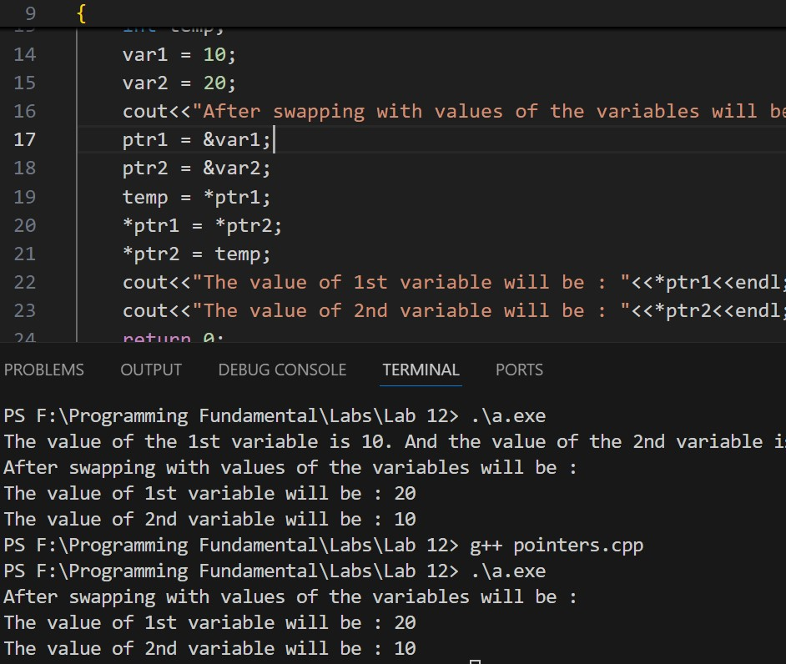

- Write a C++ program that uses a pointer to dynamically allocate memory for an array and then performs basic operations on the array such as inserting and deleting elements.

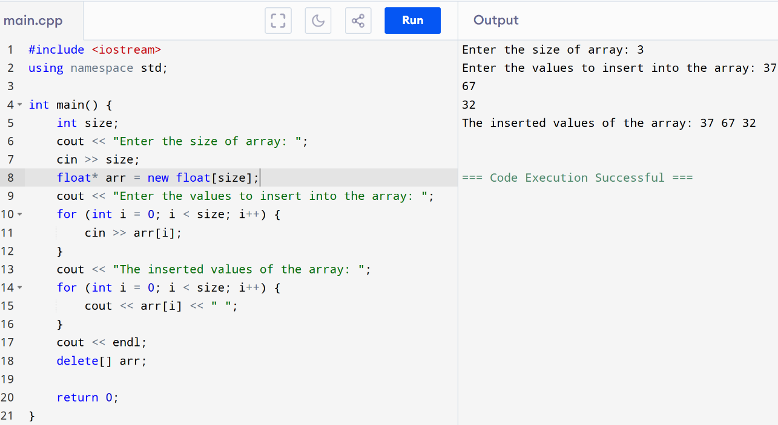

- Write a C++ function that takes an array and its size as input and returns the largest element in the array using pointers.

int size;
cout << "Enter the size of the array: ";
cin >> size;
float* arr = new float[size];
cout << "Enter the values for the array: ";
for (int i = 0; i < size; i++) {
cin >> arr[i];
}
float largest = *arr;
for (int i = 1; i < size; i++) {
if (*(arr + i) > largest) {
largest = *(arr + i);
}
}
cout << "The largest element in the array is: " << largest << endl;
return 0;
}

